Global Analysis missing values

We count for each feature ( all columns but API and target) how many missing values it has.

nb of nans in column | amount of columns
0 | 22
1 | 1
9 | 1
14 | 2
97 | 5
98 | 7
99 | 3
103 | 1
105 | 1
128 | 1
(Table 1)

We want to know whether the columns with missing values have them in the same lines.
We have 22 complete features.We clearly have a jump in the above table between nb_na= 14 and nb_na = 97.
According to that, we devide the features into two groups
feature_group1: less then 14 missing values (26 members)
feature_group2. more than 97 missing values. (18 members)

Analyze feature group2
We want to confirm that in feature-group2, the missing values are in the same lines. Hence we look only at the columns of feature-group 2 now and count for each row the number of missing values.

 | amount of rows
nb of nas per row
0 | 317
1 | 40
2 | 2
3 | 3
5 | 1
18 | 97
(Table 2)
We can confirm, that there is 97 lines, that are empty in all the feature group 2.
We define:

rows_group 2 the 97 lines with 18 missing features.
rows_group 1 all other lines.

Columns between 1 and 14 missing lines
We take a look again at table 1 with all rows and columns.
What about the first part, the columns which have between 1 and 14 missing entries.
These are:

'Date Production' 1 missing
'Pressure_PPLS (PSI)' 9 missing
Date_Drilling and Date_Completition 14 missing

nb of nans in column | amount of columns
0 | 22
1 | 1
9 | 1
14 | 2
97 | 5
98 | 7
99 | 3
103 | 1
105 | 1
128 | 1

And it turns out… that the majority of the missing values of these features are in the row_group 2 ( 97 lines with 18 or more missing features)

Columns with more than 99 missing lines

ShutInPressureInitilal (103)
Frac Gradient (105)
ShutInPressure_Fil (128)

Turns out that the two “ ShutInPressure” have missing values in mostly different lines (apart from the 97 lines ). As they are highly correlated, we can impute them easily.
Missing values of Frac Gradient can be reduced to 97 missing values by imputation as well.

Overview of the Analysis
without target and API

The main tendencies of the global Analysis of missing values can be summarized as follows.

After some impuatation, of a small percentage of values, we can bring the data into a shape...
 | 26features  feature_group 1 | 18 features  feature_group 2
 | A | B
97 rows (row_group1) | C | Missing

Where A, B , C are complete.

For the test set, we have the same structure.

Strategy for model building:
model 1 for A B= dataset 1 with all 43 features but only 363 rows
model 2 for A C =dataset 2 with all rows but only 26features.

(in the end we had to delete one line from AB ( and add it to C) because it had too many missing values in feature group 2.
PCA
What if feature-group2 is does not contain useful information, or all the variance of the features in feature group 2 can be explained by feature group 1.
→> Make a Pca on the 363 lines ( AB)

Cumulative explained variance | Only feature-group1  number of princ. comp. | All 43 features  number of princ. Comp.
80% | 6 | 11
95% | 10 | 21
99% | 15 | 30

We can see, that when we use all the features, we need a significantly higher number of prinicipal components to explain a certain percentage of variance than when considering just feature-group1.
We are not looking at absoulte variances here, as certain features have been normalized by TOTAL.

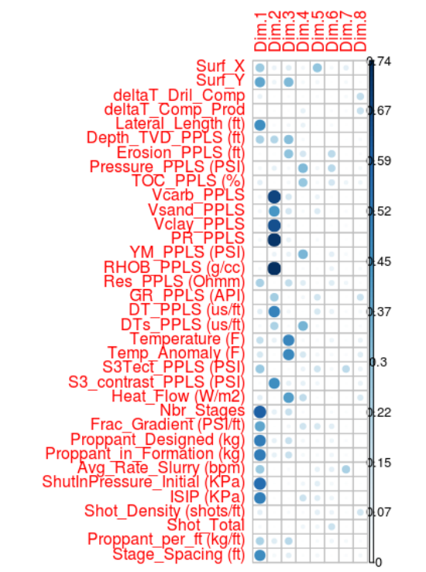
Below the contribution to the eight most important pcs are shown

For visibility reasons, some features with low contribution to the first pc have been cut out.
However , its clearly visible, that features of feature-group2 have important contrinbution to the main pcs.

To conlcude we can say that feature_group 2 carries important information.
So we decide to go ahead with the above described strategy of making two models.

